# **LAB WORK 3 (52102118080)**

1. **Creating an indexed array**

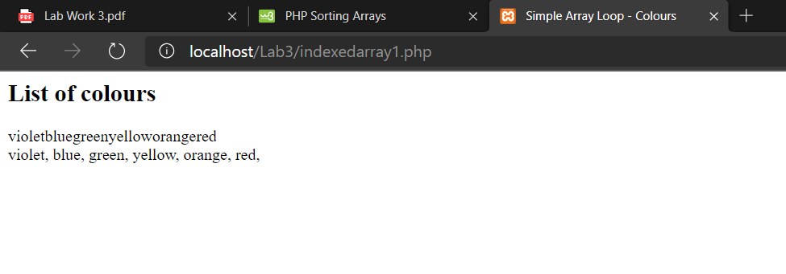

**Try This**

1. **Sorting an array – Indexed Type**

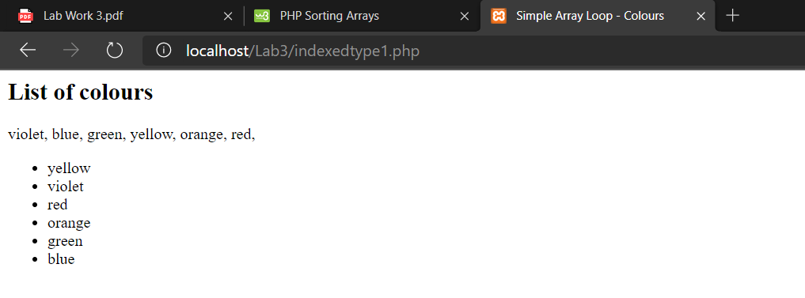

Shuffle () = sorting the arrays in random order

Asort () = sorting the arrays ascending based on value

Arsort () = sorting the arrays descending based on value

Ksort () = sorting the arrays ascending based on key

1. **Creating an associative array**

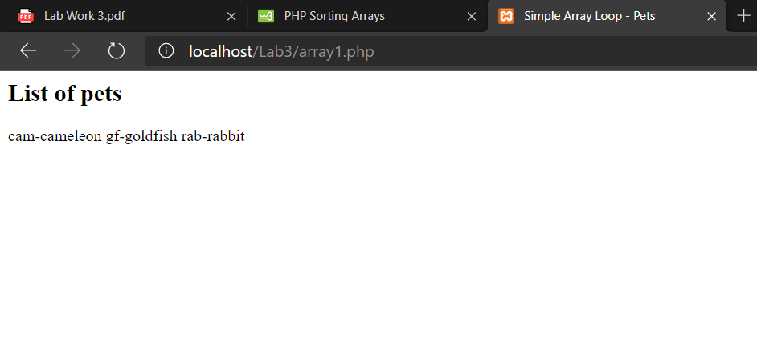

**Try This**

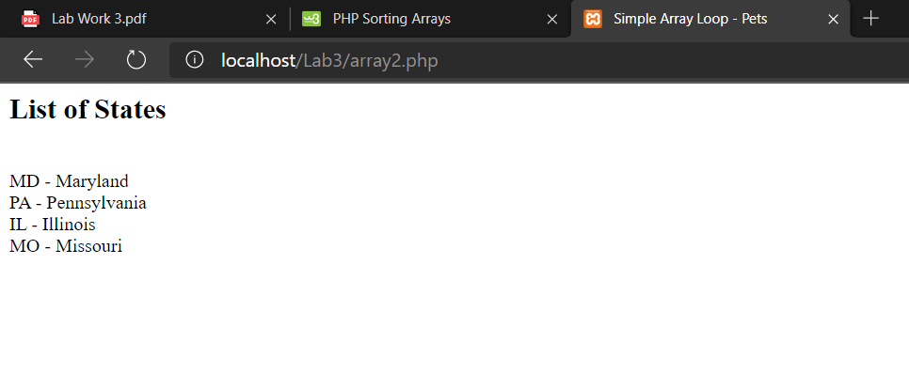

1. **Creating a pulldown menu**

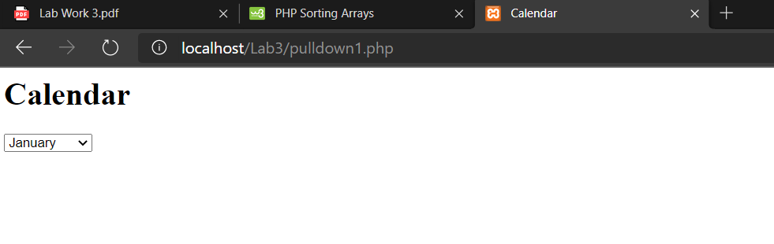

**Pulldown 2**

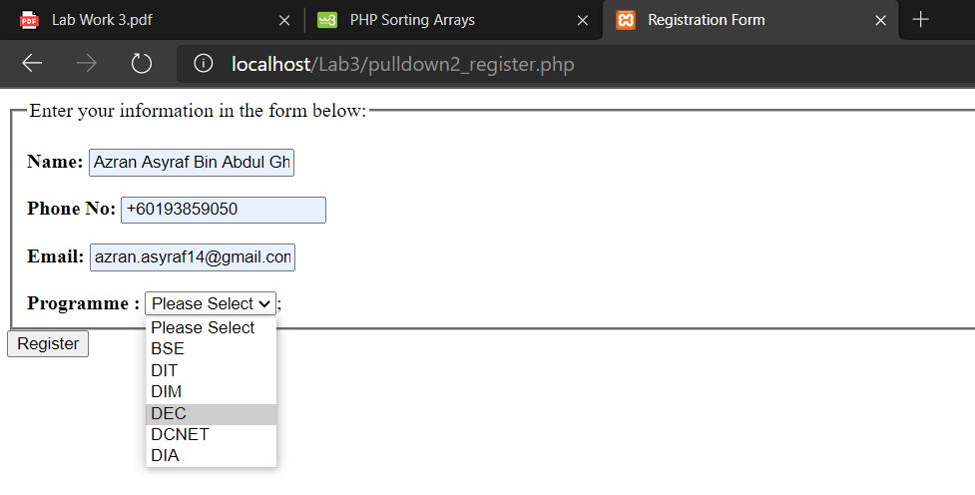

1. **The php codes display the TV channel using if…else statements a follow**

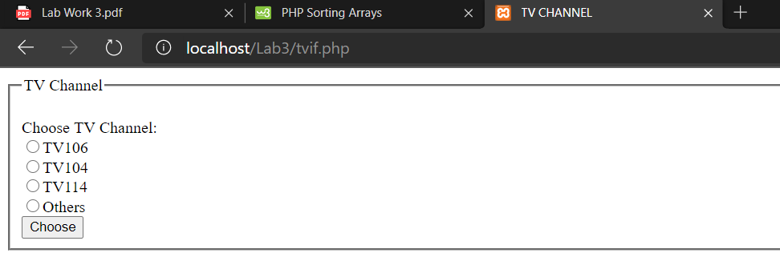

**For switch statements**



**6.Loops 1**

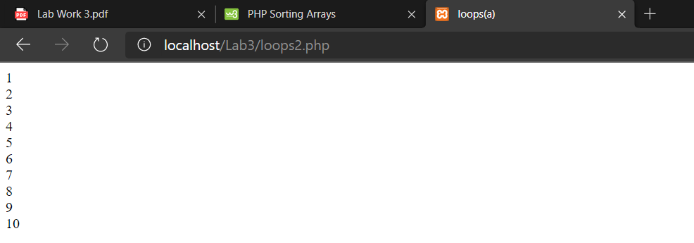

**Loops 2**

